**Q. Build a simple calculator using React that can perform basic arithmetic operations: addition, subtraction, multiplication, and division.**

import React, { useState } from "react";

function App() {

const [num1, setNum1] = useState("");

const [num2, setNum2] = useState("");

const [result, setResult] = useState("");

const handleOperation = (operator) => {

const a = parseFloat(num1);

const b = parseFloat(num2);

if (isNaN(a) || isNaN(b)) {

setResult("Please enter valid numbers");

return;

}

switch (operator) {

case "+":

setResult(a + b);

break;

case "-":

setResult(a - b);

break;

case "*":

setResult(a * b);

break;

case "/":

setResult(b !== 0 ? a / b : "Cannot divide by zero");

break;

default:

setResult("Unknown operation");

}

};

return (

<div style={{ textAlign: "center", marginTop: "100px" }}>

<h1>Simple React Calculator</h1>

<input

type="number"

placeholder="Enter first number"

value={num1}

onChange={(e) => setNum1(e.target.value)}

/>

<br />

<input

type="number"

placeholder="Enter second number"

value={num2}

onChange={(e) => setNum2(e.target.value)}

/>

<br />

<div style={{ margin: "10px" }}>

<button onClick={() => handleOperation("+")}>+</button>

<button onClick={() => handleOperation("-")}>-</button>

<button onClick={() => handleOperation("*")}>*</button>

<button onClick={() => handleOperation("/")}>/</button>

</div>

<h2>Result: {result}</h2>

</div>

);

}

export default App;

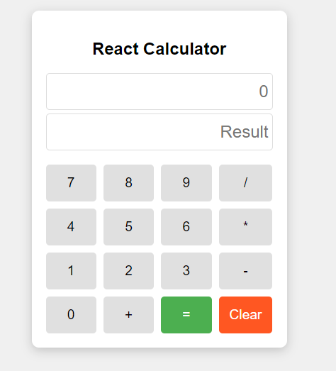

**Q.**  **Build a multi-page React application using React Router to demonstrate routing between different components.**

import React from 'react';

import { BrowserRouter as Router, Routes, Route, Link } from 'react-router-dom';

function Home() {

return <h2>🏠 Welcome to the Home Page</h2>;

}

function About() {

return <h2>📄 This is the About Page</h2>;

}

function Contact() {

return <h2>📞 Contact us at: contact@example.com</h2>;

}

function Navbar() {

return (

<nav style={{ padding: '10px', backgroundColor: '#f0f0f0' }}>

<ul style={{ display: 'flex', gap: '15px', listStyle: 'none' }}>

<li><Link to="/">Home</Link></li>

<li><Link to="/about">About</Link></li>

<li><Link to="/contact">Contact</Link></li>

</ul>

</nav>

);

}

function App() {

return (

<Router>

<div>

<Navbar />

<div style={{ padding: '20px' }}>

<Routes>

<Route path="/" element={<Home />} />

<Route path="/about" element={<About />} />

<Route path="/contact" element={<Contact />} />

</Routes>

</div>

</div>

</Router>

);

}

export default App;

import React from 'react';

import ReactDOM from 'react-dom/client';

import App from './App';

const root = ReactDOM.createRoot(document.getElementById('root'));

root.render(

<React.StrictMode> <App /> </React.StrictMode>

);

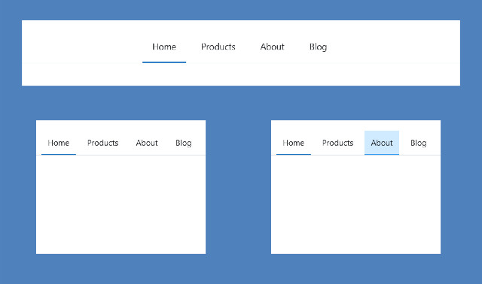

**Q.** **Create a React component that fetches a list of users from the API https://jsonplaceholder.typicode.com/users using axios and displays their names and email addresses in a list.**

import React, { useEffect, useState } from 'react';

import axios from 'axios';

function UserList() {

const [users, setUsers] = useState([]);

const [loading, setLoading] = useState(true);

const [error, setError] = useState(null);

useEffect(() => {

axios

.get('https://jsonplaceholder.typicode.com/users')

.then((response) => {

setUsers(response.data);

setLoading(false);

})

.catch((err) => {

setError('Failed to fetch users');

setLoading(false);

});

}, []);

if (loading) return <p>Loading users...</p>;

if (error) return <p>{error}</p>;

return (

<div>

<h2>User List</h2>

<ul>

{users.map((user) => (

<li key={user.id}>

<strong>{user.name}</strong> – {user.email}

</li>

))}

</ul>

</div>

);

}

export default UserList;

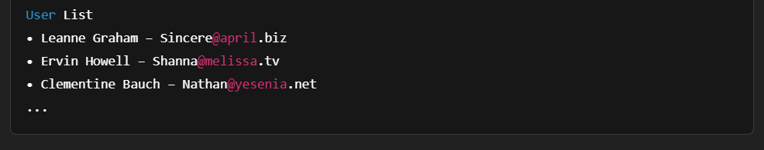

**Q. Create a simple CRUD (Create, Read, Update, Delete) web application using PHP and MySQL.**

<?php include('header.php'); ?>

<?php include('dbcon.php'); ?>

<div class="box1">

<h2> All Data </h2>

<button class="btn btn-primary" data-toggle="modal" data-target="#exampleModal"> Add Data</button>

</div>

<table class="table table-hover table-bordered table-striped">

<tr>

<th> ID </th> <th> First Name </th> <th> Last Name </th> <th> Section </th> <th> Update </th> <th> Delete </th>

</tr>

<?php

$query = "SELECT * FROM `student-data`";

$result = mysqli_query($connection,$query);

if(!$result)

{ die("query-failed".mysqli_error());

}

else {

while($row=mysqli_fetch_assoc($result)){ ?>

<tr> <td> <?php echo $row['Roll']; ?> </td>

<td> <?php echo $row['First Name']; ?> </td>

<td> <?php echo $row['Last Name']; ?> </td>

<td> <?php echo $row['Section']; ?> </td>

<td> <a href="update_page.php?id=<?php echo $row['Roll']; ?> " class="btn btn-success" > Update </a> </td>

<td> <a href="delete_page.php?id=<?php echo $row['Roll']; ?> " class="btn btn-danger" > Delete </a> </td>

</tr>

<?php } } ?>

</table>

<?php

if(isset($_GET['message'])){

echo"<h6>".$_GET['message']."</h6>"; } ?> <?php

if(isset($_GET['insert_msg'])){

echo"<h6>".$_GET['insert_msg']."</h6>"; } ?>

<?php

if (isset($_GET['update_msg'])) {

echo '<div class="alert alert-success">'.htmlspecialchars($_GET['update_msg']).'</div>';

}

if (isset($_GET['insert_msg'])) {

echo '<div class="alert alert-success">'.htmlspecialchars($_GET['insert_msg']).'</div>'; }

if (isset($_GET['message'])) {

echo '<div class="alert alert-danger">'.htmlspecialchars($_GET['message']).'</div>'; }

if (isset($_GET['delete_msg'])) {

echo '<div class="alert alert-danger">'.htmlspecialchars($_GET['delete_msg']).'</div>'; } ?>

<form action="insert_data.php" method="post">

<!-- Modal -->

<div class="modal fade" id="exampleModal" tabindex="-1" role="dialog" aria-labelledby="exampleModalLabel" aria-hidden="true">

<div class="modal-dialog" role="document">

<div class="modal-content">

<div class="modal-header">

<h5 class="modal-title" id="exampleModalLabel">Modal title</h5>

<button type="button" class="close" data-dismiss="modal" aria-label="Close">

<span aria-hidden="true">&times;</span>

</button> </div>

<div class="modal-body">

<div class="form-group">

<label for="f_name">First Name </label>

<input type="text" name="f_name" class="form-control"> </div>

<div class="form-group">

<label for="l_name">Last Name </label>

<input type="text" name="l_name" class="form-control"> </div>

<div class="form-group">

<label for="section">Section </label>

<input type="text" name="section" class="form-control">

</div> </div>

<div class="modal-footer">

<button type="button" class="btn btn-secondary" data-dismiss="modal">Close</button>

<input type="submit" class="btn btn-success" name="add_students" value="ADD">

</div>

</div> </div> </div>

</form>

<?php include('footer.php'); ?>

